**Region-wide Planning for Resurvey of Vertebrate Diversity over the Last 100 Years in the Great Basin and Mojave Desert**

CA-CESU TA#:J8C07100014

**RESURVEY SITE SELECTION**

**Submitted by: Karen Rowe, MVZ, UC Berkeley**

**Report date: 2 September 2011**

The purpose of this report is to inform NPS staff of the results of preliminary site selection for resurvey of vertebrates in the Great Basin and Mojave Desert regions. The contents of this report will be discussed at the in-person meetings or conference call with each of the participating national parks, including DEVA, MOJA, JOTR, GRBA, and LAKE. A brief update of additional progress since the last report (30 June 2011) is also given, including NPSpecies data, regional museum records, and ungeoreferenced specimen data. Comments should be directed to Karen Rowe (karenrowe@berkeley.edu).

*Methods of site selection*

I performed a spatial density analysis to identify localities within each park and nearby areas with high sampling densities for each taxa, using all the georeferenced specimens available at the time of the analysis (1 July 2011). These specimens include those with collecting dates prior to 1970, but with unknown quality of the georeference. Areas with high sampling densities were identified and resurvey site lists were generated by grouping neighboring localities within a 2 km diameter (Figures 1 – 5). This grouping criterion is used to increase sample sizes for historic to modern comparisons and to reduce spatial autocorrelation among sites (Moritz et al. 2008, *Science* 322:261). For each identified resurvey site I generated an approximate centroid for the collection of localities included in that site (Figures 6 – 10) and extracted an elevation at that coordinate using Google Earth (v. 6.0.3), which uses DEM data generated from NASA’s SRTM. Results from resurvey site selection using this method are presented here (Tables 1-5).

*Additional methods of site selection*

In addition to choosing resurvey sites based on the location of existing historical museum records, we are also working on generating a list of additional sites using the output of the species distribution models. These additional sites will provide a baseline for future inventories, allow for empirical testing of species distribution model output by identifying localities where species are thought to expand into or have contracted out of, and areas where models differ on their prediction of a species’ presence, and finally, to help to identify areas with high species richness. As the output of the species distribution models are still in progress, the results from this part of the project will be presented at a later date, but feedback from the parks on the utility of these approaches will be appreciated.

*Other updates*

*NPSpecies data*

The comparison of NPSpecies data with the data compiled from national and regional museum is one of the goals of this project and will allow NPS to confirm the presence of species records within the park and also to evaluate whether new records exist since they were last reviewed. I have recently learned that NPS is involved in a large-scale certification of species records within the Mojave Network parks, including those within the scope of MVZ's planning grant (JOTR, MOJA, GRBA, DEVA, LAKE) and at present, the data from NPSpecies was not available for evaluation. On 12 August 2011, I spoke with Jennifer Stingelin-Keefer, NPSpecies Project Manager, regarding the status of NPSpecies data within the Mojave Desert Network. This work involves verifying species records based on non-digitized National Park reports, museum voucher records from regionally-relevant museums, and observation records. The observation records are subjective evidence (no physical proof taken) as to the identity and the location of an organism and are only included if the source is credible, e.g., park biologist. Digitization of these reports is still in process for many parks and evaluation of park records cannot begin until this process is completed. Additional data entry errors and missing data issues also need to be addressed. At present, the use of these data (with some exceptions given below) would be premature to include in the MVZ-NPS planning grant because the source(s) of inconsistencies between the data mined as part of this planning grant and NPSpecies data would be difficult to identify until the NPSpecies data have been certified. Furthermore, many of the inconsistencies between the data sets that are apparent now may be rectified without further evaluation once the NPSpecies data have been certified.

Jennifer has provided some of the data that have gone through an initial evaluation phase, including all data from GRBA, mammals from DEVA, JOTR, LAKE, and MOJA, and birds from JOTR (which were not listed in the I & M report from the survey done in 2002). These records will be incorporated into the general specimen database and will be available in the final version of the data at the completion of the project, with the caveat that these records have not yet been certified. In addition, museum records compiled as part of this report will be made available to Jennifer and others involved in the certification process so they can hopefully assist with evaluating park records based on vouchered specimens.

*Regional museum records*

Additional regional museums that were queried since the last report include:

Majorie Barrick Museum (UNLV) – birds only (John Klicka)

Nevada State Museum (George Baumgardner)

Museum of Northern Arizona (Janet Gillette)

San Bernardino County Museum (sent to secretary, Rhonda Almager)

I have received records from Majorie Barrick Museum. Records are being generated at Nevada State Museum and Museum of Northern Arizona. I should be receiving the records from MNA within the week, but NSM is severely understaffed and many of the relevant records are not digitized so they have to manually enter some of these data, but are working to provide the data as quickly as possible. As of today, I have not yet received a reply from San Bernardino County Museum. Follow up emails with NSM and SBCM will be sent.

*Ungeoreferenced specimen data*

A total of 16,833 specimen records representing 3892 unique localities do not have georeferences associated with the record. I have tried to automate georeferencing of these records using BioGeomancer, but have had some trouble with the upload and generation of the georeferences. I will try again when I am at the MVZ, where I will have access to one of the program’s developers. As mentioned in the last report, if this method of georeferencing does not work, it may be useful to evaluate whether a subset of these records may make an important contribution to the project. We may be able to do this by creating a list of localities from these remaining records and using the verbal locality description as to whether they may be within or outside of the park boundaries with assistance from park personnel. This matter will be discussed during the in-person visits and conference call (LAKE).

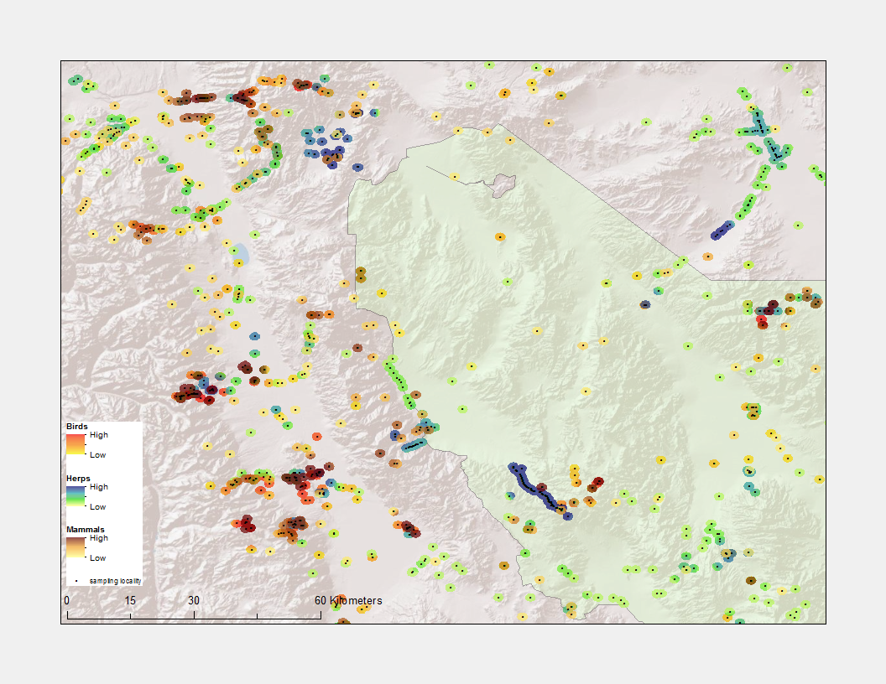

Figure 1a. Historic (i.e., pre-1970) vertebrate sampling densities in the north of Death Valley NP. Darker colors indicate more concentrated sampling within each taxa. The diameter of the colored circles is 2 km.

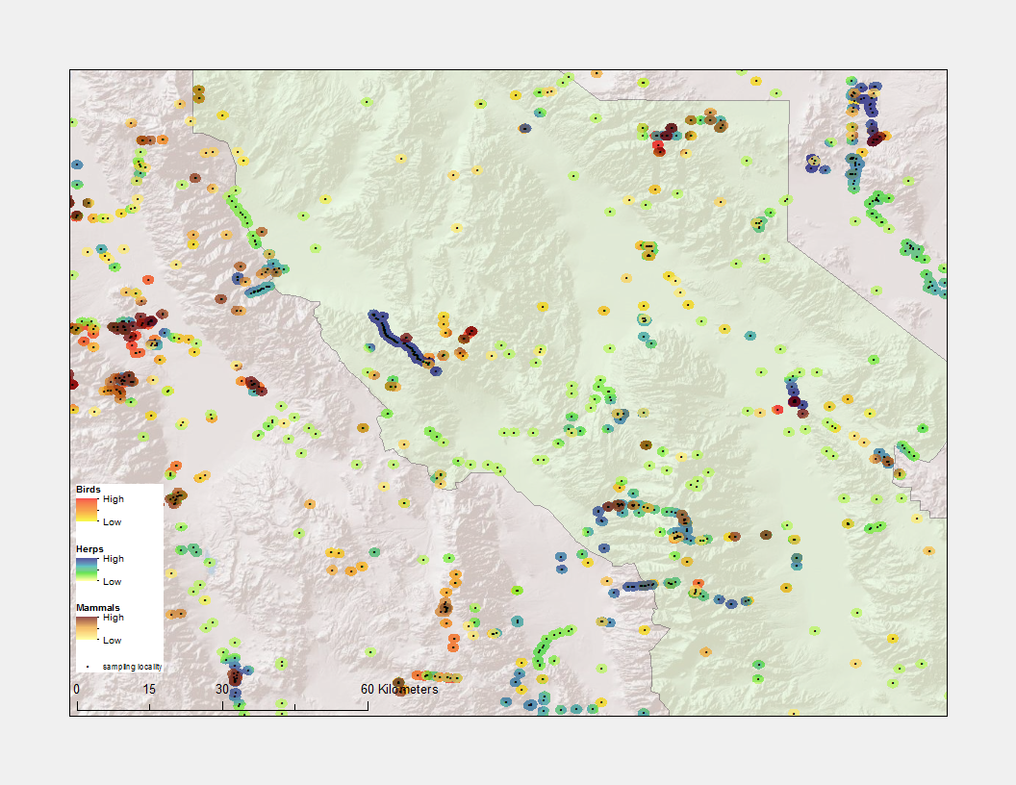

Figure 1b. Historic vertebrate sampling densities in central Death Valley NP.

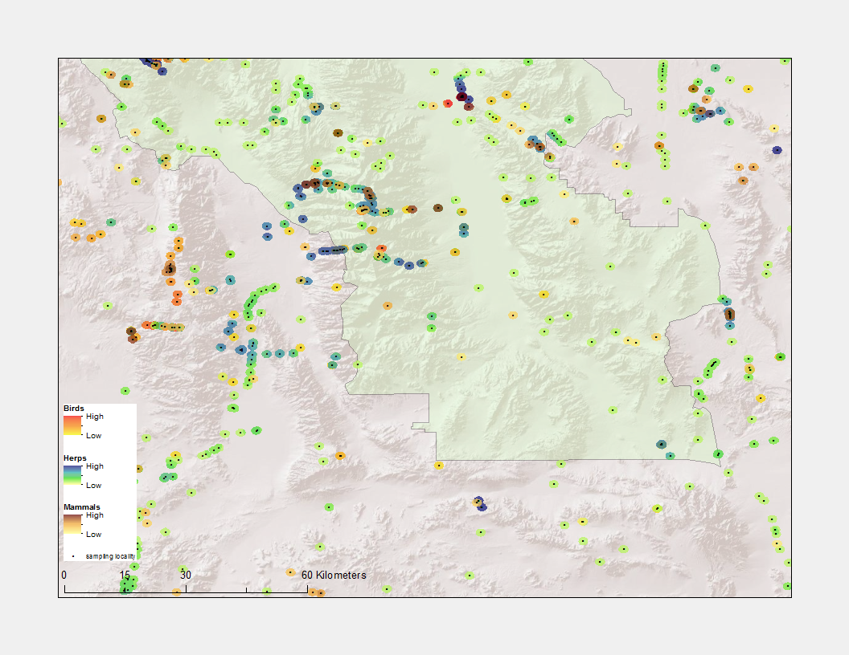

Figure 1c. Historic vertebrate sampling densities in the south of Death Valley NP.

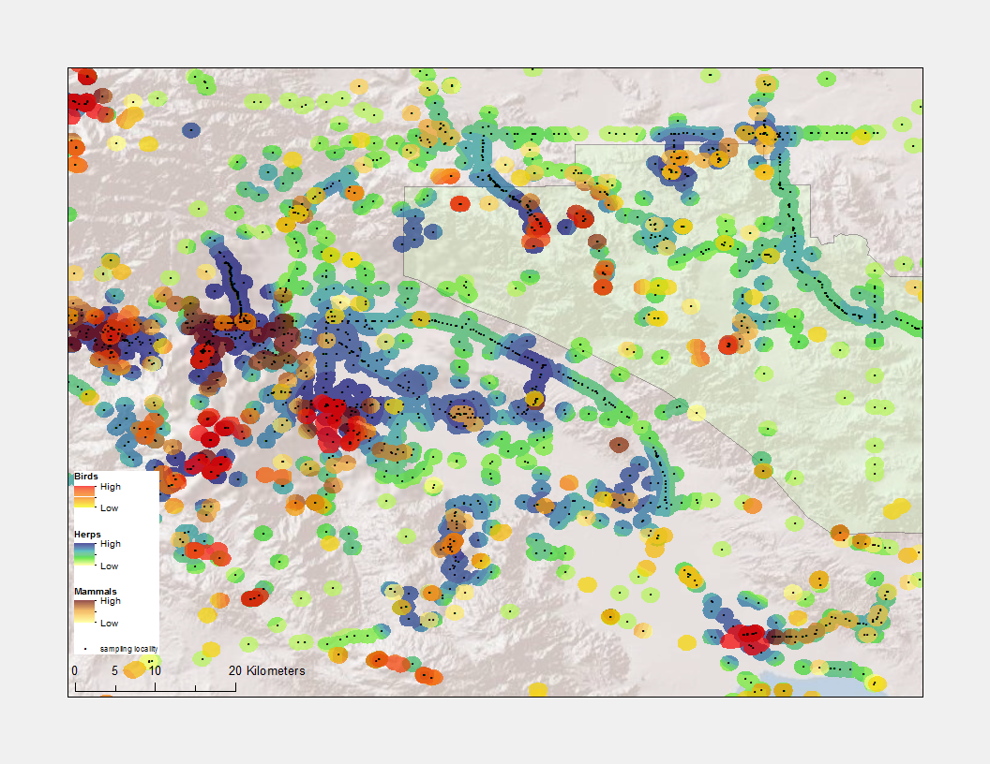

Figure 2a. Historic vertebrate sampling densities in the west of Joshua Tree NP.

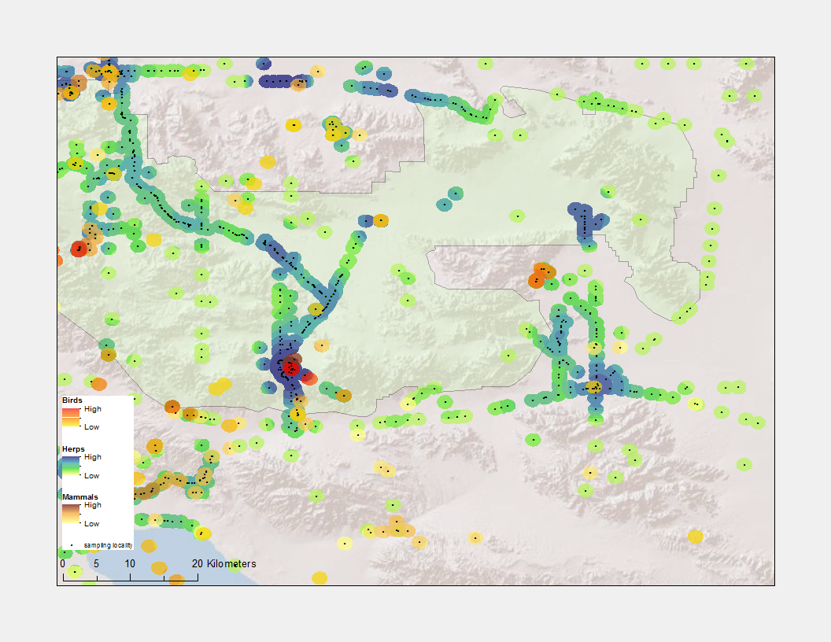

Figure 2b. Historic vertebrate sampling densities in the east of Joshua Tree NP.

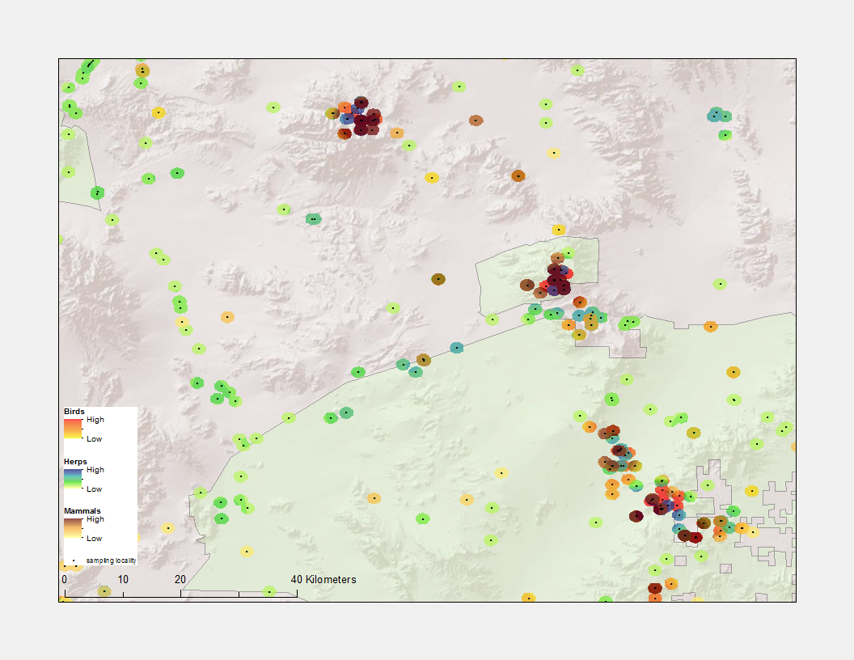

Figure 3a. Historic vertebrate sampling densities in the north of Mojave NP, including the Kingston Range.

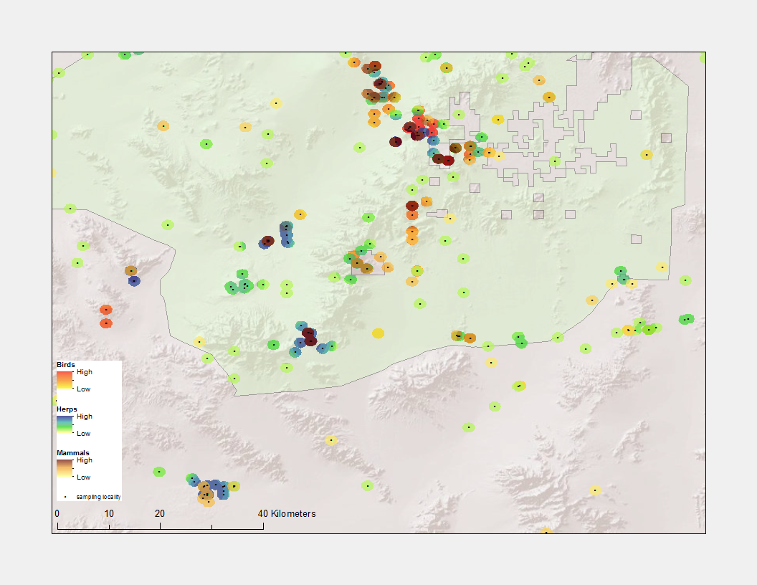

Figure 3b. Historic vertebrate sampling densities in the south of Mojave NP.

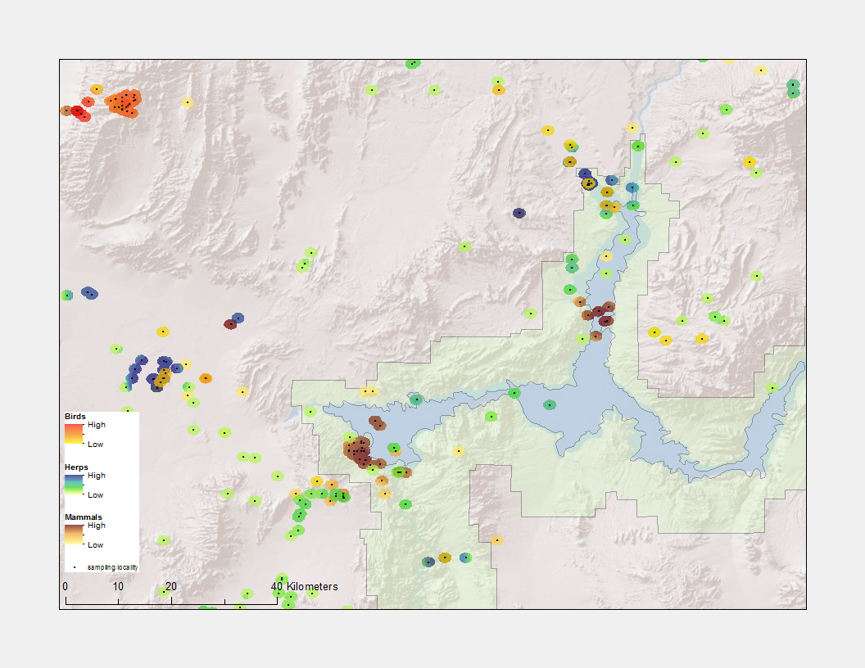

Figure 4a. Historic vertebrate sampling densities in the north of Lake Mead NRA.

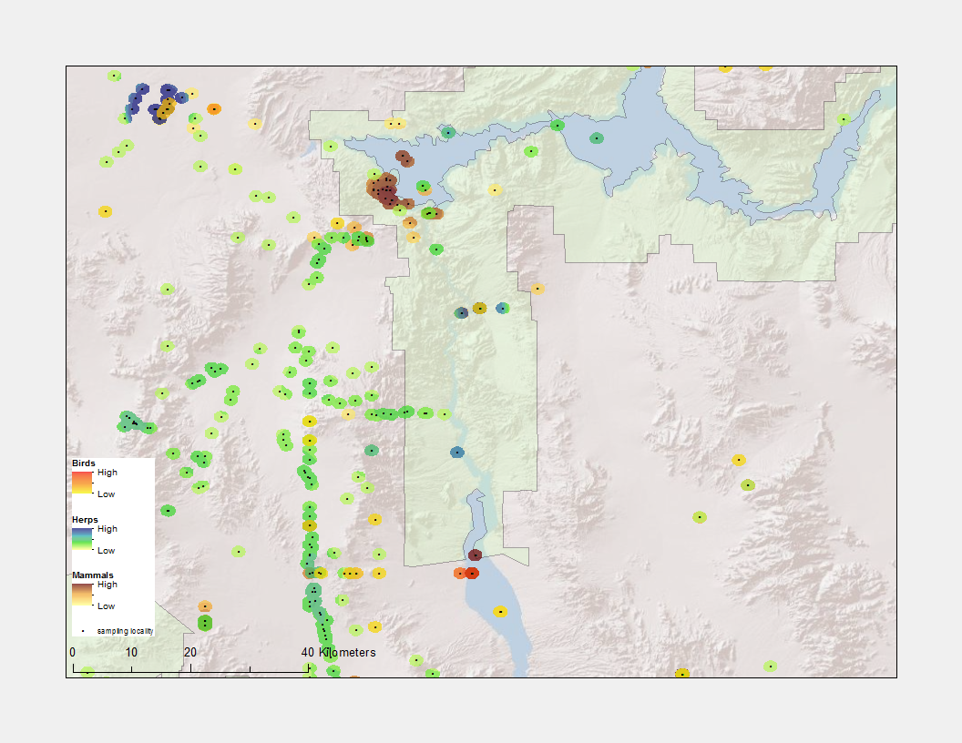

Figure 4b. Historic vertebrate sampling densities in the south of Lake Mead NRA.

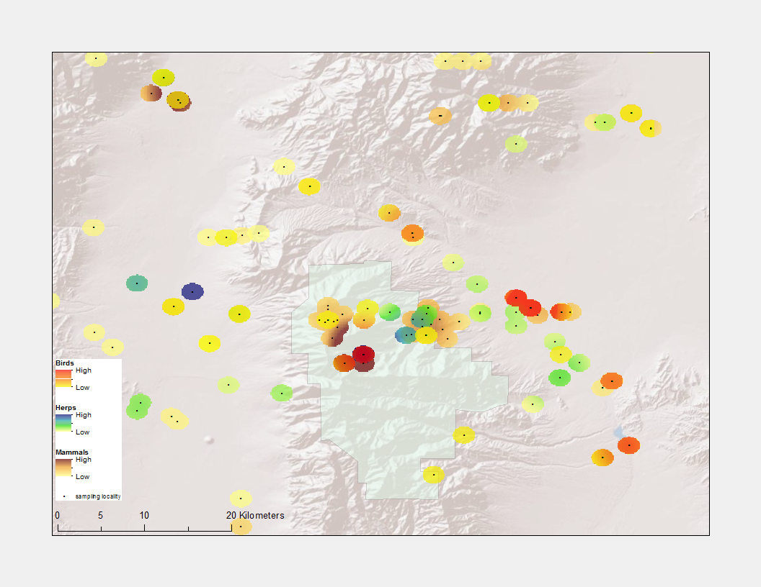

Figure 5. Historic vertebrate sampling densities in Great Basin NP.

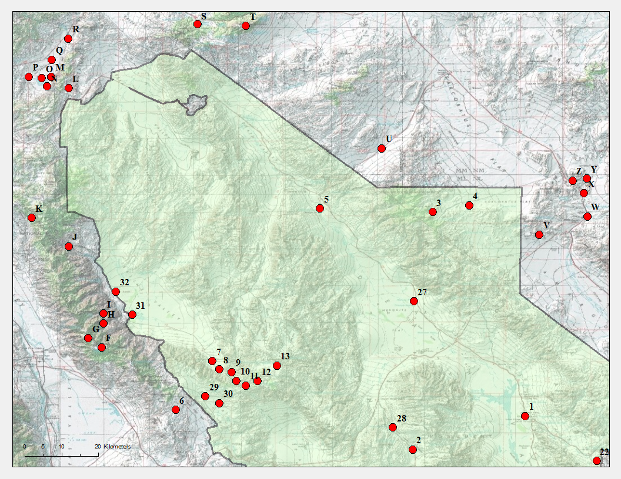

Figure 6a. Map of proposed resurvey sites encompassing northern Death Valley NP.

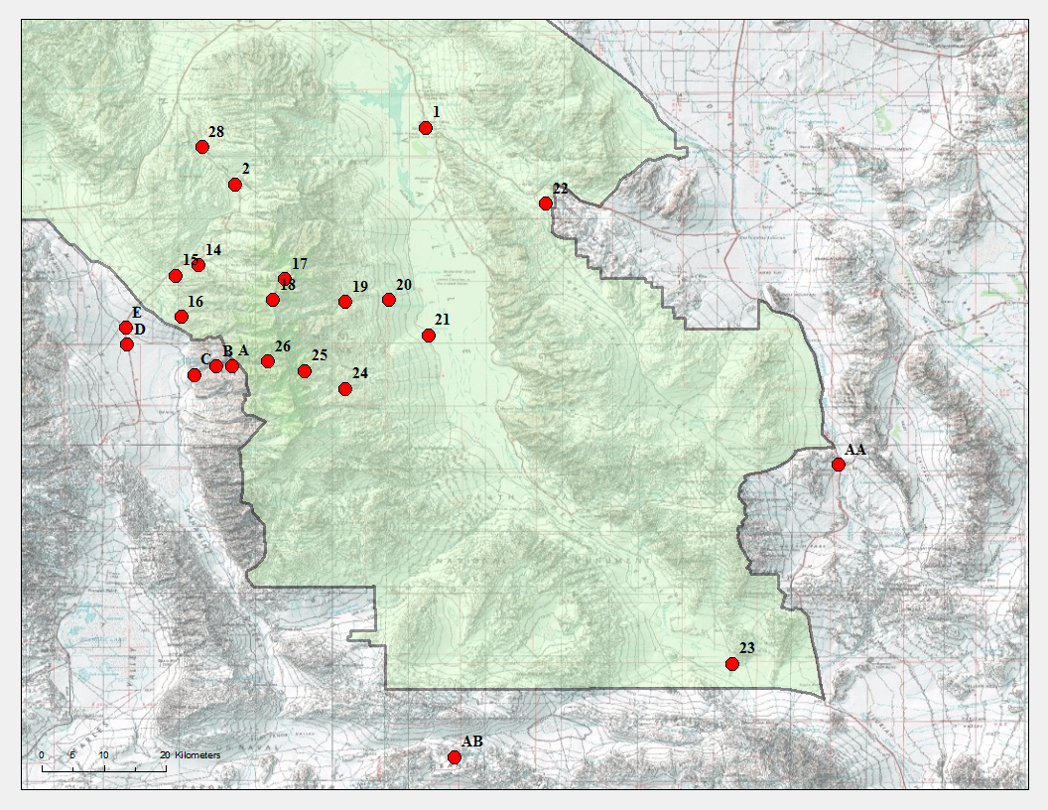

Figure 6b. Map of proposed resurvey sites encompassing southern Death Valley NP.

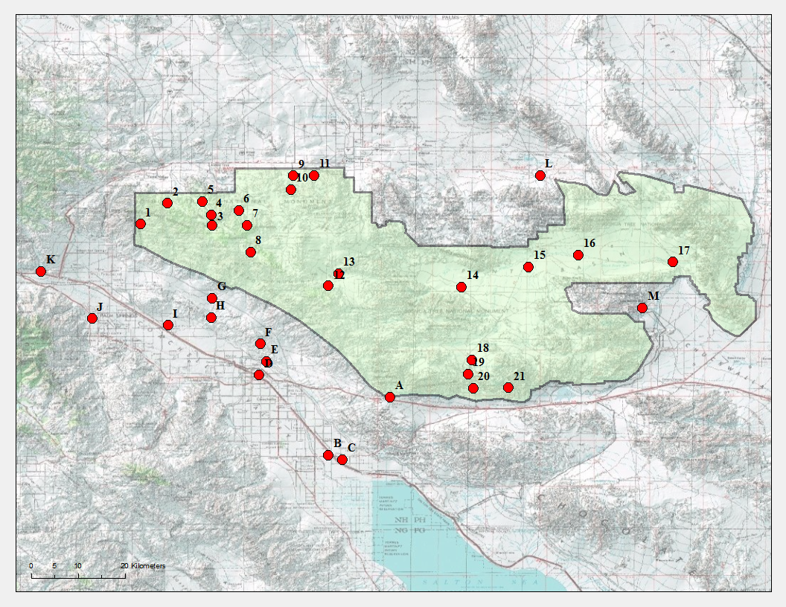

Figure 7. Map of proposed resurvey sites encompassing Joshua Tree NP.

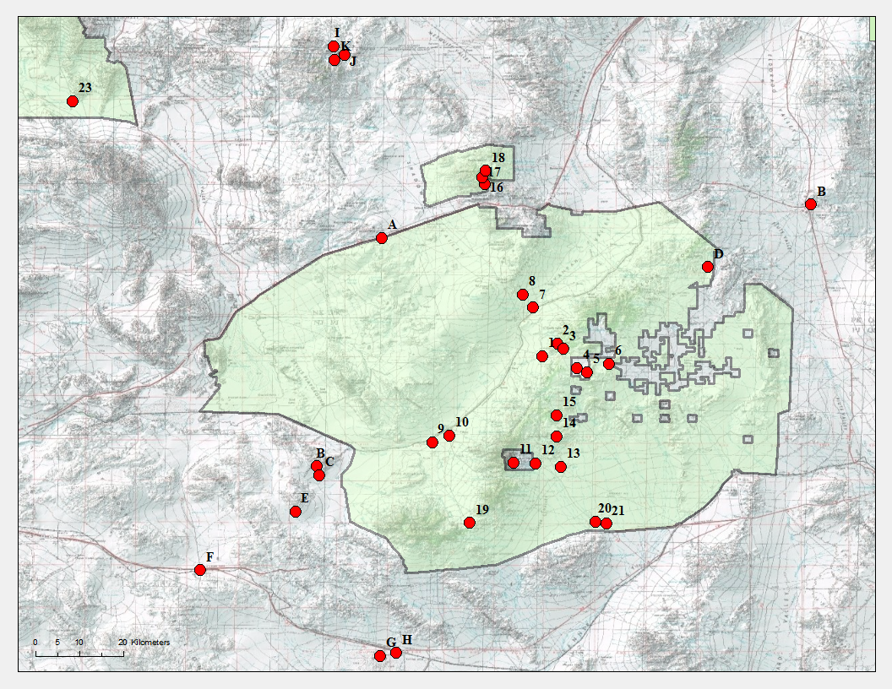

Figure 8. Map of proposed resurvey sites encompassing Mojave NP and the Kingston Range.

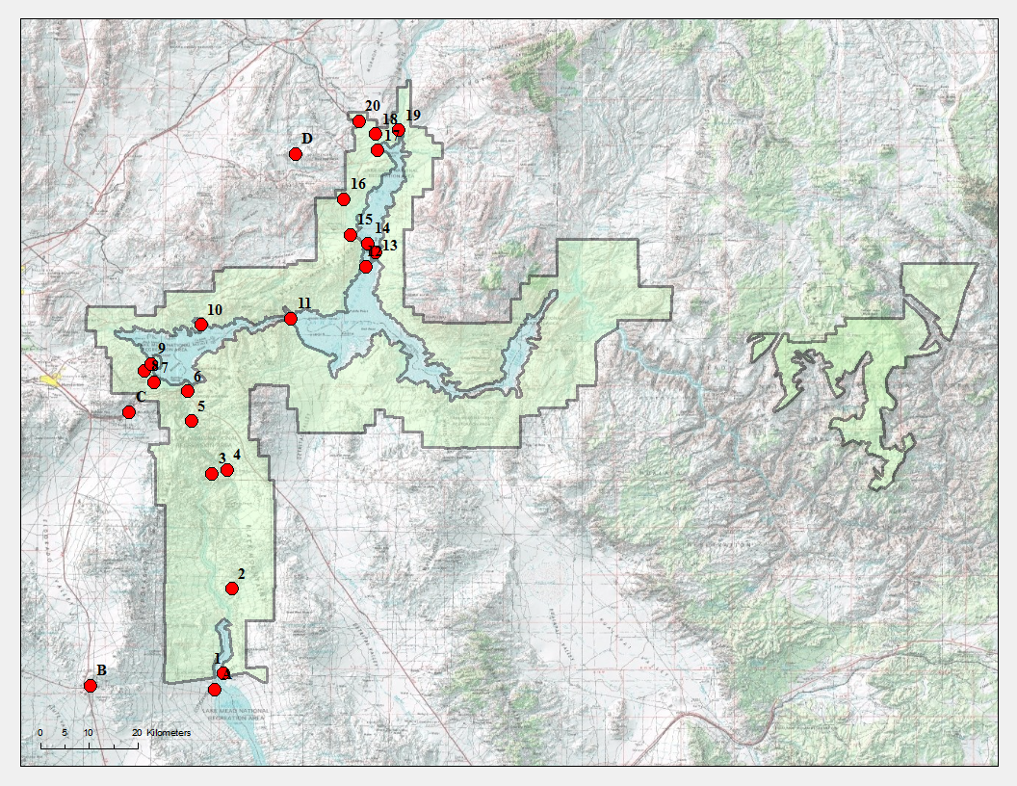

Figure 9. Map of proposed resurvey sites encompassing Lake Mead NRA.

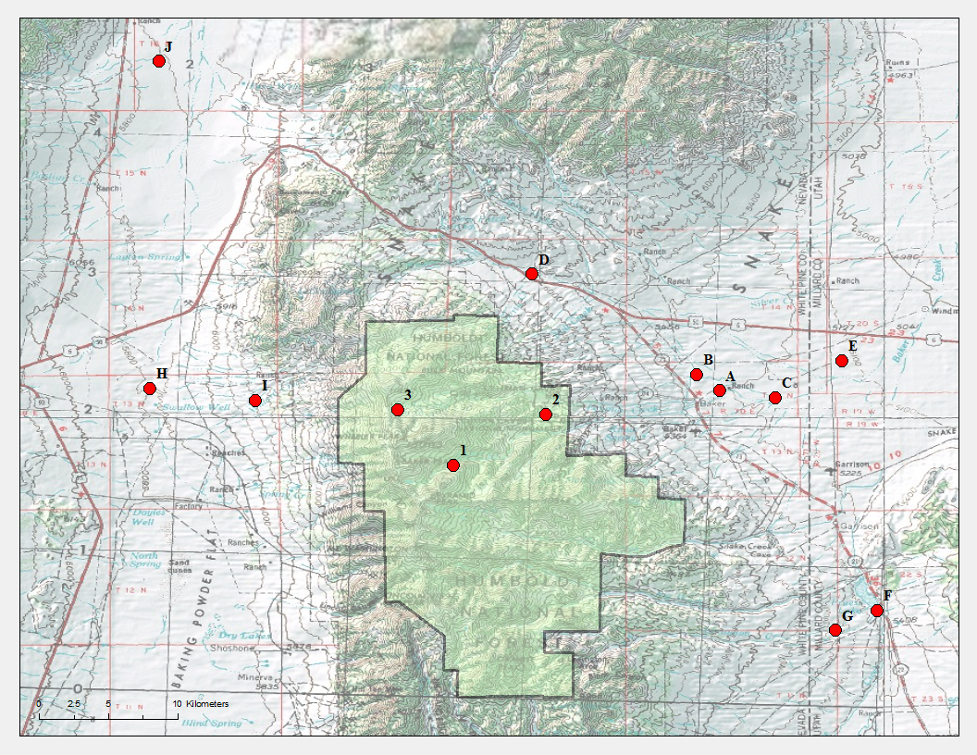

Figure 10. Map of proposed resurvey sites encompassing Great Basin NP.

Table 1. Preliminary site list for resurveys in Death Valley NP. Numbered and lettered sites are those within and outside of park boundaries, respectively.

|  |  |  |  |  |  |  |  |  |  |  |
| --- | --- | --- | --- | --- | --- | --- | --- | --- | --- | --- |
|  | *Within Park sites* |  |  |  |  | No. of specimens | | |  |  |
| Site no. | **Locality** | **elevation (m)** | **latitude** | **longitude** |  | **Birds** | **Herps** | **Mammals** |  | **Total** |
| 1 | Furnace Creek | -52 | 36.458 | -116.866 |  | 341 | 185 | 324 |  | 850 |
| 2 | Emigrant Canyon, Panamint Mountains | 1495 | 36.376 | -117.141 |  | 1 | 4 | 93 |  | 98 |
| 3 | 2.5 mi E + 1 mi S Grapevine Peak | 2210 | 36.956 | -117.092 |  | 186 | 31 | 230 |  | 447 |
| 4 | 8 mi E Grapevine Peak | 1493 | 36.973 | -117.003 |  | 0 | 19 | 36 |  | 55 |
| 5 | Mesquite Spring | 562 | 36.965 | -117.367 |  | 12 | 77 | 0 |  | 89 |
| 6 | Saline Valley, Lower Grapevine Canyon (1) | 1905 | 36.473 | -117.719 |  | 0 | 82 | 0 |  | 82 |
| 7 | Saline Valley, Lower Grapevine Canyon (2) | 929 | 36.592 | -117.629 |  | 0 | 159 | 0 |  | 159 |
| 8 | Saline Valley, Lower Grapevine Canyon (3) | 1131 | 36.572 | -117.612 |  | 0 | 204 | 0 |  | 204 |
| 9 | Saline Valley, Lower Grapevine Canyon (4) | 1397 | 36.565 | -117.582 |  | 0 | 304 | 125 |  | 429 |
| 10 | Nelson Mountains, Grapevine Canyon | 1591 | 36.544 | -117.57 |  | 0 | 508 | 0 |  | 508 |
| 11 | 2 mi SW Jackass Spring | 1855 | 36.532 | -117.547 |  | 9 | 236 | 10 |  | 255 |
| 12 | Jackass Spring | 2111 | 36.543 | -117.519 |  | 21 | 2 | 9 |  | 32 |
| 13 | 3 mi NE Jackass Spring | 1969 | 36.581 | -117.472 |  | 70 | 1 | 142 |  | 213 |
| 14 | Wildrose Canyon | 1528 | 36.259 | -117.194 |  | 4 | 29 | 102 |  | 135 |
| 15 | Nemo Canyon | 1084 | 36.244 | -117.227 |  | 0 | 62 | 0 |  | 62 |
| 16 | Jail Canyon | 677 | 36.18444 | -117.21944 |  | 0 | 52 | 0 |  | 52 |
| 17 | Mahogany Flat | 2349 | 36.239 | -117.069 |  | 1 | 30 | 41 |  | 72 |
| 18 | Hanaupah Canyon (West) | 2825 | 36.209 | -117.087 |  | 23 | 7 | 5 |  | 35 |
| 19 | Hanaupah Canyon (West) | 760 | 36.206 | -116.982 |  | 1 | 0 | 72 |  | 73 |
| 20 | Hanaupah Canyon (East) | 203 | 36.2089 | -116.9186 |  | 0 | 15 | 76 |  | 91 |
| 21 | Bennett's Well | -69 | 36.158 | -116.862 |  | 2 | 34 | 0 |  | 36 |
| 22 | 2 mi NW Ryan | 693 | 36.348 | -116.692 |  | 20 | 44 | 51 |  | 115 |
| 23 | Saratoga Springs | 60 | 35.683 | -116.423 |  | 1 | 32 | 0 |  | 33 |
| 24 | Johnson Canyon (East) | 938 | 36.08019 | -116.98241 |  | 0 | 71 | 0 |  | 71 |
|  | ***Within Park sites (cont.)*** |  |  |  |  | **No. of specimens** | | |  |  |
| Site no. | **Locality** | **elevation (m)** | **latitude** | **longitude** |  | **Birds** | **Herps** | **Mammals** |  | **Total** |
| 25 | Johnson Canyon (West) | 1895 | 36.106 | -117.041 |  | 42 | 15 | 5 |  | 62 |
| 26 | Panamint City | 2009 | 36.12 | -117.094 |  | 10 | 14 | 0 |  | 24 |
| 27 | Triangle Spring/Midway Well | 16 | 36.738 | -117.138 |  | 17 | 13 | 20 |  | 50 |
| 28 | Emigrant Spring | 1270 | 36.43 | -117.189 |  | 10 | 39 | 7 |  | 56 |
| 29 | Lee Flat, 15 mi N Darwin | 1698 | 36.505733 | -117.646657 |  | 0 | 1 | 20 |  | 21 |
| 30 | South of Lee Flat, near Wilson Ranch | 1639 | 36.489 | -117.612 |  | 7 | 12 | 26 |  | 45 |
| 31 | Saline Valley | 330 | 36.705 | -117.825 |  | 0 | 13 | 33 |  | 46 |
| 32 | Saline Valley, North Sand Dunes | 363 | 36.762 | -117.864 |  | 0 | 4 | 42 |  | 46 |
|  |  |  |  | ***Totals*** |  | 778 | 2299 | 1469 |  | 4546 |
|  |  |  |  |  |  |  |  |  |  |  |
|  |  |  |  |  |  |  |  |  |  |  |
|  | ***Outside of Park sites*** |  |  |  |  | **No. of specimens** | | |  |  |
| Site no. | **Locality** | **elevation (m)** | **latitude** | **longitude** |  | **Birds** | **Herps** | **Mammals** |  | **Total** |
| A | Surprise Canyon (East) | 1344 | 36.114 | -117.146 |  | 1 | 51 | 0 |  | 52 |
| B | Surprise Canyon (Central) | 928 | 36.113 | -117.169 |  | 0 | 57 | 0 |  | 57 |
| C | Surprise Canyon (West) | 524 | 36.101111 | -117.200833 |  | 0 | 26 | 0 |  | 26 |
| D | Panamint Valley (South) | 361 | 36.14514 | -117.29788 |  | 0 | 37 | 0 |  | 37 |
| E | Panamint Valley (North) | 401 | 36.168828 | -117.299567 |  | 0 | 21 | 0 |  | 21 |
| F | Craig Canyon Pass | 2817 | 36.626 | -117.899 |  | 0 | 0 | 25 |  | 25 |
| G | New York Butte | 3239 | 36.647922 | -117.931694 |  | 0 | 0 | 58 |  | 58 |
| H | Big Hunter Canyon | 1737 | 36.684 | -117.895 |  | 0 | 90 | 6 |  | 96 |
| I | Beveridge Canyon | 1437 | 36.708208 | -117.895473 |  | 0 | 0 | 43 |  | 43 |
| J | Paiute Creek | 1223 | 36.872095 | -117.979751 |  | 0 | 0 | 62 |  | 62 |
| K | Mazourka Canyon | 2616 | 36.942 | -118.07 |  | 8 | 0 | 68 |  | 76 |
| L | Deep Springs Valley, 8 mi S Deep Springs School | 1816 | 37.259 | -117.98 |  | 0 | 69 | 0 |  | 69 |
| M | Deep Springs Lake (East) | 1511 | 37.287 | -118.022 |  | 0 | 83 | 15 |  | 98 |
| N | Deep Springs Lake (Southeast) | 1509 | 37.263 | -118.033 |  | 0 | 69 | 0 |  | 69 |
|  | ***Outside of Park sites (cont.)*** |  |  |  |  | **No. of specimens** | | |  |  |
| Site no. | **Locality** | **elevation (m)** | **latitude** | **longitude** |  | **Birds** | **Herps** | **Mammals** |  | **Total** |
| O | Deep Springs Lake (West) | 1501 | 37.283 | -118.045 |  | 0 | 29 | 21 |  | 50 |
| P | Deep Springs Valley (West) | 1542 | 37.287 | -118.077 |  | 0 | 30 | 0 |  | 30 |
| Q | Deep Springs Valley (Central) | 1534 | 37.328 | -118.021 |  | 0 | 87 | 2 |  | 89 |
| R | Deep Springs | 1593 | 37.38 | -117.981 |  | 7 | 197 | 16 |  | 220 |
| S | Pigeon Spring | 1970 | 37.415 | -117.666 |  | 4 | 0 | 15 |  | 19 |
| T | Magruder Mountain | 2745 | 37.411 | -117.547 |  | 24 | 6 | 13 |  | 43 |
| U | Grapevine Canyon, 10 mi NE Scotty's Castle | 1263 | 37.112 | -117.216 |  | 0 | 226 | 0 |  | 226 |
| V | Bullfrog Mine, 0.5 mi N of Rhyolite | 1163 | 36.901 | -116.832 |  | 0 | 180 | 2 |  | 182 |
| W | Amargosa River, 3.5 mi NE Beatty | 1064 | 36.945 | -116.715 |  | 13 | 138 | 183 |  | 334 |
| X | Hwy US 95, 7.9 mi N Beatty | 1112 | 37.002 | -116.723 |  | 0 | 95 | 0 |  | 95 |
| Y | Amargosa River, 2 mi E Springdale | 1167 | 37.038 | -116.716 |  | 0 | 27 | 1 |  | 28 |
| Z | Amargosa River, 1 mi NE Springdale | 1178 | 37.033 | -116.751 |  | 3 | 32 | 21 |  | 56 |
| AA | Shoshone | 478 | 35.971 | -116.27 |  | 14 | 41 | 44 |  | 99 |
| AB | Granite Mountains | 1200 | 35.549 | -116.824 |  | 0 | 255 | 4 |  | 259 |
|  |  |  |  | ***Totals*** |  | 74 | 1846 | 599 |  | 2519 |

Table 2. Preliminary site list for resurveys in Joshua Tree NP. Numbered and lettered sites are those within and outside of park boundaries, respectively.

|  |  |  |  |  |  |  |  |  |  |  |  |  |  |  |  |  |  |  |  |  |
| --- | --- | --- | --- | --- | --- | --- | --- | --- | --- | --- | --- | --- | --- | --- | --- | --- | --- | --- | --- | --- |
|  | *Within Park sites* | | |  | |  | |  | | |  | No. of specimens | | | | | |  | |  |
| Site no. | **Locality** | | | **elevation (m)** | | **latitude** | | **longitude** | | |  | **Birds** | | **Herps** | | **Mammals** | |  | | **Total** |
| 1 | | 3.5 mi N + 2.5 mi E Desert Hot Springs | 739 | | 34.016 | | -116.447 | |  | 0 | | | 138 | | 0 | |  | | 138 | |
| 2 | | Black Rock Spring | 1355 | | 34.056 | | -116.395 | |  | 160 | | | 71 | | 20 | |  | | 251 | |
| 3 | | Upper Covington Flat | 1483 | | 34.013 | | -116.309 | |  | 11 | | | 33 | | 0 | |  | | 44 | |
| 4 | | Lower Covington Flat (South) | 1461 | | 34.034 | | -116.311 | |  | 107 | | | 464 | | 67 | |  | | 638 | |
| 5 | | Lower Covington Flat (North) | 1378 | | 34.06 | | -116.328 | |  | 0 | | | 35 | | 18 | |  | | 53 | |
| 6 | | Quail Spring | 1123 | | 34.042 | | -116.258 | |  | 97 | | | 80 | | 144 | |  | | 321 | |
| 7 | | 13 mi SW Twentynine Palms | 1525 | | 34.013766 | | -116.241221 | |  | 0 | | | 2 | | 41 | |  | | 43 | |
| 8 | | Stubby Spring | 1380 | | 33.962 | | -116.235 | |  | 89 | | | 49 | | 40 | |  | | 178 | |
| 9 | | Indian Cove (North) | 883 | | 34.109 | | -116.153 | |  | 7 | | | 113 | | 18 | |  | | 138 | |
| 10 | | Indian Cove (South) | 1141 | | 34.083 | | -116.157 | |  | 5 | | | 106 | | 5 | |  | | 116 | |
| 11 | | Fortynine Palms | 1032 | | 34.11 | | -116.113 | |  | 6 | | | 87 | | 3 | |  | | 96 | |
| 12 | | Pinyon Well | 1261 | | 33.898 | | -116.085 | |  | 113 | | | 59 | | 26 | |  | | 198 | |
| 13 | | 1.5 mi NE Pinyon Well | 1003 | | 33.921 | | -116.066 | |  | 0 | | | 35 | | 12 | |  | | 47 | |
| 14 | | 5 mi NW Old Dale Junction | 560 | | 33.895 | | -115.829 | |  | 0 | | | 90 | | 0 | |  | | 90 | |
| 15 | | Pinto Peak | 454 | | 33.934 | | -115.7 | |  | 9 | | | 114 | | 9 | |  | | 132 | |
| 16 | | Pinto Wash West | 391 | | 33.95681 | | -115.60458 | |  | 0 | | | 30 | | 0 | |  | | 30 | |
| 17 | | Pinto Wash Well | 329 | | 33.943 | | -115.422 | |  | 0 | | | 139 | | 0 | |  | | 139 | |
| 18 | | Cottonwood Spring (North) | 982 | | 33.755 | | -115.809 | |  | 0 | | | 15 | | 15 | |  | | 30 | |
| 19 | | Cottonwood Spring (South) | 881 | | 33.727 | | -115.817 | |  | 216 | | | 233 | | 111 | |  | | 560 | |
| 20 | | 3 mi S Cottonwood Spring | 708 | | 33.7 | | -115.807 | |  | 0 | | | 17 | | 11 | |  | | 28 | |
| 21 | | Lost Palm Canyon | 782 | | 33-701072 | | -115.73925 | |  | 11 | | | 24 | | 0 | |  | | 35 | |
|  | |  |  | |  | | ***Totals*** | |  | 831 | | | 1934 | | 540 | |  | | 3305 | |
|  | |  |  | |  | |  | |  |  | | |  | |  | |  | |  | |
|  | |  |  | |  | |  | |  |  | | |  | |  | |  | |  | |
|  | ***Outside of Park sites*** | | |  | |  | |  | | |  | **No. of specimens** | | | | | |  | |  |
| Site no. | **Locality** | | | **elevation (m)** | | **latitude** | | **longitude** | | |  | **Birds** | | **Herps** | | **Mammals** | |  | | **Total** |
| A | | Colorado River, Riverside Mountains | 525 | | 33.683 | | -115.967 | |  | 43 | | | 15 | | 0 | |  | | 58 | |
| B | | Mecca (West) | -58 | | 33.571 | | -116.085 | |  | 670 | | | 109 | | 2 | |  | | 781 | |
| C | | Mecca (East) | -53 | | 33.563 | | -116.058 | |  | 126 | | | 13 | | 217 | |  | | 356 | |
| D | | Indio | -3 | | 33.725 | | -116.219 | |  | 0 | | | 66 | | 33 | |  | | 99 | |
| E | | 0.5 mi SE Hwy 71 at junction Hwy 74 | 31 | | 33.752 | | -116.205 | |  | 0 | | | 76 | | 0 | |  | | 76 | |
| F | | Curtis Palms | 262 | | 33.785526 | | -116.216728 | |  | 0 | | | 0 | | 119 | |  | | 119 | |
| G | | Dillon Road | 276 | | 33.873 | | -116.309 | |  | 0 | | | 168 | | 0 | |  | | 168 | |
| H | | Thousand Palms | 159 | | 33.836 | | -116.311 | |  | 1 | | | 113 | | 139 | |  | | 253 | |
| I | | Edom | 77 | | 33.821 | | -116.394 | |  | 0 | | | 186 | | 28 | |  | | 214 | |
| J | | Palm Springs | 149 | | 33.834 | | -116.54 | |  | 179 | | | 423 | | 302 | |  | | 904 | |
| K | | Whitewater | 417 | | 33.925 | | -116.638 | |  | 20 | | | 214 | | 144 | |  | | 378 | |
| L | | 22 mi E Twentynine Palms | 411 | | 34.11 | | -115.678 | |  | 0 | | | 72 | | 0 | |  | | 72 | |
| M | | N side of Eagle Mountain | 395 | | 33.855 | | -115.481 | |  | 43 | | | 14 | | 4 | |  | | 61 | |
|  | |  |  | |  | | ***Totals*** | |  | 1082 | | | 1469 | | 988 | |  | | 3539 | |

Table 3. Preliminary site list for resurveys in Mojave NP. Numbered and lettered sites are those within and outside of park boundaries, respectively.

|  |  |  |  |  |  |  |  |  |  |  |  |  |  |  |  |  |  |  |  |  |
| --- | --- | --- | --- | --- | --- | --- | --- | --- | --- | --- | --- | --- | --- | --- | --- | --- | --- | --- | --- | --- |
|  | *Within Park sites* | |  | |  | | |  | | |  | No. of specimens | | | | | |  | |  |
| Site no. | **Locality** | | **elevation (m)** | | **latitude** | | | **longitude** | | |  | **Birds** | | **Herps** | | **Mammals** | |  | | **Total** |
| 1 | | Cedar Canyon (West), Providence Mountains | | 1335 | | 35.16 | -115.461 | |  | 7 | | | 179 | | 57 | |  | | 243 | |
| 2 | | 5 mi SE Cima | | 1708 | | 35.186 | -115.431 | |  | 9 | | | 2 | | 9 | |  | | 20 | |
| 3 | | Cedar Canyon (East), Providence Mountains | | 1539 | | 35.175 | -115.418 | |  | 208 | | | 74 | | 46 | |  | | 328 | |
| 4 | | 5 mi NE Granite Well (West), Providence Mountains | | 1586 | | 35.136 | -115.391 | |  | 9 | | | 13 | | 140 | |  | | 162 | |
| 5 | | 5 mi NE Granite Well (East), Providence Mountains | | 1615 | | 35.12722 | -115.369 | |  | 116 | | | 0 | | 10 | |  | | 126 | |
| 6 | | Rock Spring | | 1538 | | 35.145 | -115.325 | |  | 11 | | | 15 | | 19 | |  | | 45 | |
| 7 | | 2 mi NE Cima | | 1230 | | 35.26 | -115.48 | |  | 36 | | | 26 | | 40 | |  | | 102 | |
| 8 | | 3 mi N Cima | | 1324 | | 35.287 | -115.501 | |  | 46 | | | 1 | | 48 | |  | | 95 | |
| 9 | | 2.5 mi SW Kelso | | 605 | | 34.984 | -115.687 | |  | 5 | | | 106 | | 66 | |  | | 177 | |
| 10 | | Kelso | | 643 | | 34.998 | -115.651 | |  | 5 | | | 33 | | 0 | |  | | 38 | |
| 11 | | Mitchel Caverns | | 1433 | | 34.943 | -115.52 | |  | 33 | | | 17 | | 23 | |  | | 73 | |
| 12 | | Essex | | 1019 | | 34.94053 | -115.475 | |  | 0 | | | 0 | | 9 | |  | | 9 | |
| 13 | | Colton Well, Providence Mountains | | 964 | | 34.93414 | -115.424 | |  | 9 | | | 2 | | 0 | |  | | 11 | |
| 14 | | 5 mi S Granite Well, Providence Mountains | | 1498 | | 34.996 | -115.432 | |  | 23 | | | 0 | | 6 | |  | | 29 | |
| 15 | | 6 mi S Granite Well, Providence Mountains | | 1347 | | 35.04 | -115.432 | |  | 25 | | | 0 | | 110 | |  | | 135 | |
| 16 | | SE side Clark Mountain | | 1921 | | 35.512 | -115.58 | |  | 150 | | | 58 | | 62 | |  | | 270 | |
| 17 | | N side Clark Mountain | | 2309 | | 35.526 | -115.585 | |  | 20 | | | 26 | | 25 | |  | | 71 | |
| 18 | | NE Clark Mountain | | 2044 | | 35.54 | -115.577 | |  | 45 | | | 3 | | 30 | |  | | 78 | |
| 19 | | Pass between Granite and Providence Mountains | | 1229 | | 34.819 | -115.61 | |  | 6 | | | 65 | | 112 | |  | | 183 | |
| 20 | | 8.5 mi NW Essex | | 670 | | 34.822 | -115.352 | |  | 0 | | | 7 | | 5 | |  | | 12 | |
| 21 | | 7 mi NW Essex | | 638 | | 34.8171 | -115.331 | |  | 1 | | | 0 | | 21 | |  | | 22 | |
|  | |  | |  | |  | ***Totals*** | |  | 764 | | | 627 | | 838 | |  | | 2229 | |

|  |  |  |  |  |  |  |  |  |  |  |  |  |  |  |  |  |  |  |  |  |
| --- | --- | --- | --- | --- | --- | --- | --- | --- | --- | --- | --- | --- | --- | --- | --- | --- | --- | --- | --- | --- |
|  | *Outside of Park sites* | |  | |  | | |  | | |  | No. of specimens | | | | | |  | |  |
| Site no. | **Locality** | | **elevation (m)** | | **latitude** | | | **longitude** | | |  | **Birds** | | **Herps** | | **Mammals** | |  | | **Total** |
| A | | Yucca Grove | | 1261 | | 35.402 | -115.79 | |  | 0 | | | 5 | | 20 | |  | | 25 | |
| B | | Colton Well, Providence Mountains | | 801 | | 34.9347 | -115.924 | |  | 2 | | | 31 | | 15 | |  | | 48 | |
| C | | 2 mi N junction Hwy 192 and Hwy 60 | | 563 | | 34.91668 | -115.918 | |  | 0 | | | 74 | | 0 | |  | | 74 | |
| D | | 9 mi W + 5 mi S Searchlight | | 1382 | | 35.343 | -115.123 | |  | 0 | | | 5 | | 27 | |  | | 32 | |
| E | | no consistent specific locality | | 777 | | 34.84265 | -115.967 | |  | 58 | | | 0 | | 0 | |  | | 58 | |
| F | | Ludlow | | 538 | | 34.722 | -116.162 | |  | 2 | | | 177 | | 25 | |  | | 204 | |
| G | | Amboy Crater Lava Flow (West) | | 226 | | 34.547 | -115.793 | |  | 0 | | | 94 | | 12 | |  | | 106 | |
| H | | Amboy Crater Lava Flow (East) | | 191 | | 34.553 | -115.76 | |  | 0 | | | 10 | | 5 | |  | | 15 | |
| I | | 2 mi N Horse Spring, Kingston Range | | 1334 | | 35.795 | -115.889 | |  | 1 | | | 13 | | 9 | |  | | 23 | |
| J | | 1 mi E Horse Spring, Kingston Range | | 1260 | | 35.778 | -115.867 | |  | 13 | | | 25 | | 4 | |  | | 42 | |
| K | | Horse Spring, Kingston Range | | 1506 | | 35.767 | -115.887 | |  | 83 | | | 79 | | 176 | |  | | 338 | |
|  | |  | |  | |  | ***Totals*** | |  | 159 | | | 513 | | 293 | |  | | 965 | |

Table 4. Preliminary site list for resurveys in Lake Mead NRA. Numbered and lettered sites are those within and outside of park boundaries, respectively.

|  |  |  |  |  |  |  |  |  |  |  |  |  |  |  |  |  |  |  |  |
| --- | --- | --- | --- | --- | --- | --- | --- | --- | --- | --- | --- | --- | --- | --- | --- | --- | --- | --- | --- |
|  | *Within Park sites* | |  | |  | |  | | |  | No. of specimens | | | | | |  | |  |
| Site no. | **Locality** | | **elevation (m)** | | **latitude** | | **longitude** | | |  | **Birds** | | **Herps** | | **Mammals** | |  | | **Total** |
| 1 | | Colorado River, 31 mi N + 2.5 mi E Camp Mohave | | 232 | | 35.4927 | | -114.666 |  | 0 | | 0 | | 49 | |  | | 49 | |
| 2 | | Colorado River, 18 mi NE Searchlight | | 346 | | 35.64991 | | -114.65 |  | 0 | | 27 | | 0 | |  | | 27 | |
| 3 | | Colorado River, 1.5 mi W and 0.5 mi S Willow Beach | | 203 | | 35.86275 | | -114.687 |  | 0 | | 1 | | 7 | |  | | 8 | |
| 4 | | Willow Beach, Colorado River | | 212 | | 35.8703 | | -114.659 |  | 0 | | 51 | | 22 | |  | | 73 | |
| 5 | | Hot Spring, Ringbolt Rapids, Black Canyon, Colorado River | | 250 | | 35.9606 | | -114.725 |  | 0 | | 5 | | 0 | |  | | 5 | |
| 6 | | Hoover Dam | | 450 | | 36.016 | | -114.732 |  | 0 | | 3 | | 44 | |  | | 47 | |
| 7 | | Boulder City (South) | | 390 | | 36.032 | | -114.794 |  | 0 | | 0 | | 59 | |  | | 59 | |
| 8 | | Boulder City (West) | | 367 | | 36.053 | | -114.811 |  | 0 | | 0 | | 17 | |  | | 17 | |
| 9 | | Boulder City (North) | | 442 | | 36.067 | | -114.799 |  | 0 | | 0 | | 6 | |  | | 6 | |
| 10 | | Callville, Colorado River | | 367 | | 36.13867 | | -114.707 |  | 0 | | 11 | | 0 | |  | | 11 | |
| 11 | | Boulder Lake, 20 mi above Dam | | 367 | | 36.15 | | -114.54 |  | 0 | | 6 | | 0 | |  | | 6 | |
| 12 | | Ramshead Island | | 367 | | 36.24672 | | -114.402 |  | 0 | | 0 | | 20 | |  | | 20 | |
| 13 | | Heron Island | | 380 | | 36.27306 | | -114.383 |  | 0 | | 0 | | 45 | |  | | 45 | |
| 14 | | Bighorn Island | | 398 | | 36.28917 | | -114.397 |  | 0 | | 0 | | 39 | |  | | 39 | |
| 15 | | Overton | | 367 | | 36.30556 | | -114.429 |  | 0 | | 0 | | 20 | |  | | 20 | |
| 16 | | 1 mi S Rogers Spring | | 461 | | 36.372 | | -114.442 |  | 0 | | 9 | | 0 | |  | | 9 | |
| 17 | | Saint Thomas | | 367 | | 36.462 | | -114.379 |  | 3 | | 5 | | 0 | |  | | 8 | |
| 18 | | 5 mi SE Overton | | 367 | | 36.49205 | | -114.383 |  | 1 | | 22 | | 3 | |  | | 26 | |
| 19 | | Boulder Lake, near mouth of Virgin River | | 367 | | 36.49944 | | -114.34 |  | 0 | | 15 | | 0 | |  | | 15 | |
| 20 | | Kaolin | | 370 | | 36.516 | | -114.414 |  | 2 | | 147 | | 3 | |  | | 152 | |
|  | |  | |  | |  | | ***Totals*** |  | 6 | | 302 | | 334 | |  | | 642 | |

|  |  |  |  |  |  |  |  |  |  |  |  |  |  |  |  |  |  |  |  |
| --- | --- | --- | --- | --- | --- | --- | --- | --- | --- | --- | --- | --- | --- | --- | --- | --- | --- | --- | --- |
|  | *Outside of Park sites* | |  | |  | |  | | |  | No. of specimens | | | | | |  | |  |
| Site no. | **Locality** | | **elevation (m)** | | **latitude** | | **longitude** | | |  | **Birds** | | **Herps** | | **Mammals** | |  | | **Total** |
| A | | 14 mi E Searchlight | | 218 | | 35.464 | | -114.681 |  | 69 | | 0 | | 164 | |  | | 233 | |
| B | | Searchlight | | 1128 | | 35.471 | | -114.912 |  | 1 | | 6 | | 27 | |  | | 34 | |
| C | | Boulder City (proper) | | 761 | | 35.977 | | -114.84 |  | 0 | | 7 | | 26 | |  | | 33 | |
| D | | Valley of Fire | | 734 | | 36.45611 | | -114.532 |  | 0 | | 70 | | 6 | |  | | 76 | |
|  | |  | |  | |  | | ***Totals*** |  | 70 | | 83 | | 223 | |  | | 376 | |

Table 5. Preliminary site list for resurveys in Great Basin NP. Numbered and lettered sites are those within and outside of park boundaries, respectively.

|  |  |  |  |  |  |  |  |  |  |  |  |  |  |  |  |  |  |  |  |
| --- | --- | --- | --- | --- | --- | --- | --- | --- | --- | --- | --- | --- | --- | --- | --- | --- | --- | --- | --- |
|  | *Within Park sites* | |  | |  | |  | | |  | No. of specimens | | | | | |  | |  |
| Site no. | **Locality** | | **elevation (m)** | | **latitude** | | **longitude** | | |  | **Birds** | | **Herps** | | **Mammals** | |  | | **Total** |
| 1 | | South Side, Baker Creek | | 2858 | | 38.96917 | | -114.28 |  | 110 | | 28 | | 238 | |  | | 376 | |
| 2 | | Lehman Cave | | 2100 | | 39.002 | | -114.22 |  | 1 | | 11 | | 63 | |  | | 75 | |
| 3 | | Stella Lake | | 3169 | | 39.005 | | -114.316 |  | 2 | | 0 | | 41 | |  | | 43 | |
|  | |  | |  | |  | | ***Totals*** |  | 113 | | 39 | | 342 | |  | | 494 | |
|  | |  | |  | |  | |  |  |  | |  | |  | |  | |  | |
|  | |  | |  | |  | |  |  |  | |  | |  | |  | |  | |
|  | |  | |  | |  | |  |  |  | |  | |  | |  | |  | |
|  | ***Outside of Park sites*** | |  | |  | |  | | |  | **No. of specimens** | | | | | |  | |  |
| Site no. | **Locality** | | **elevation (m)** | | **latitude** | | **longitude** | | |  | **Birds** | | **Herps** | | **Mammals** | |  | | **Total** |
| A | | Lehman Creek | | 1590 | | 39.01722 | | -114.107 |  | 188 | | 0 | | 12 | |  | | 200 | |
| B | | 1 mi N Baker | | 1600 | | 39.02783 | | -114.122 |  | 1 | | 0 | | 34 | |  | | 35 | |
| C | | 2.5 mi E Baker | | 1566 | | 39.013 | | -114.071 |  | 16 | | 1 | | 43 | |  | | 60 | |
| D | | Strawberry Creek | | 1842 | | 39.093 | | -114.229 |  | 70 | | 1 | | 2 | |  | | 73 | |
| E | | Mouth of Snake Creek | | 1775 | | 39.037 | | -114.028 |  | 82 | | 0 | | 15 | |  | | 97 | |
| F | | Lexington Creek | | 1638 | | 38.87472 | | -114.005 |  | 102 | | 1 | | 2 | |  | | 105 | |
| G | | 5 mi S Garrison | | 1693 | | 38.86195 | | -114.032 |  | 2 | | 1 | | 73 | |  | | 76 | |
| H | | 7 mi SW Osceola, Spring Valley | | 1757 | | 39.01881 | | -114.477 |  | 0 | | 1 | | 58 | |  | | 59 | |
| I | | Willard Creek, Spring Valley | | 1956 | | 39.01111 | | -114.408 |  | 7 | | 3 | | 40 | |  | | 50 | |
| J | | Cleve Creek, Schell Creek Range | | 1724 | | 39.231 | | -114.471 |  | 7 | | 0 | | 106 | |  | | 113 | |
|  | |  | |  | |  | | ***Totals*** |  | 475 | | 8 | | 385 | |  | | 868 | |